4TH QUESTION IS SOLVED BY USING LTSPICE

First of all, we examine the circuit structure. Since it is a differential pair, we can determine it’s gain with the half-circuit methodology.

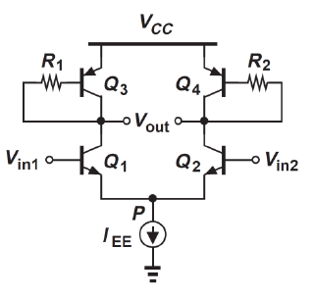When we determine the half-circuit, we can find the gain by using the short-circuit transconductance. Av = - GmRout

$$Gm ≈{gm}_{1}$$

$$Rout= [ ( {ro}_{1} // {ro}_{3} // (\frac{1}{{gm}_{3}}+\frac{R_{1}}{β+1} )]$$

Av = -GmRout

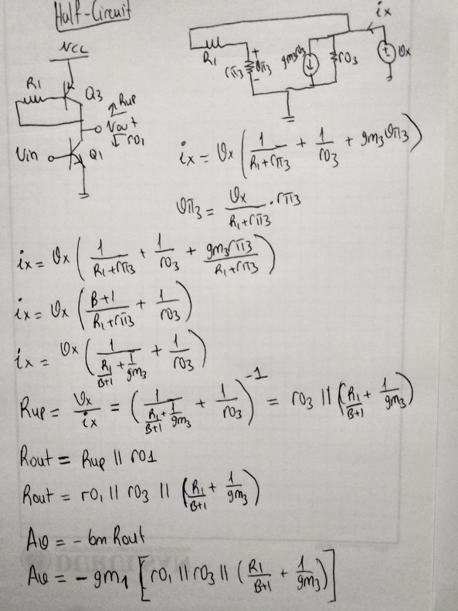 Av = ${-gm}_{1}* [ ( {ro}_{1} // {ro}_{3} // (\frac{1}{{gm}_{3}}+\frac{R_{1}}{β+1} )]$

From these gain expressions and using some electronics knowledge we can optimize the circuit for the highest gain. In the differential pair, the collector current (Ic) will be Iee/2 regardless of the the input voltages. And also, since the Iee and therefore the collector currents do not change, our small signal parameters gm, ro, and rpi do not change, too.

Therefore, the only method to increase the gain is to increase the R1 and R2 at the same time.

But, can we increase R1 and R2 (let’s call base resistances for simplicity) as much as we want?

Unfortunately, no!

Increasing base resistances reduces the collector voltage and if collector voltage decreases enough, the npn transistors can saturate. Pnp transistors cannot be in saturation mode because they are diode-connected.

The method I applied is:

To increase the gain, I should increase the base resistances.

As I increase the base resistances, the collector voltage decreases.

Therefore, to stay in active region input voltages should be very low.

But the voltage on the tail current should be greater than 0.

**The circuit which I prepared is:**

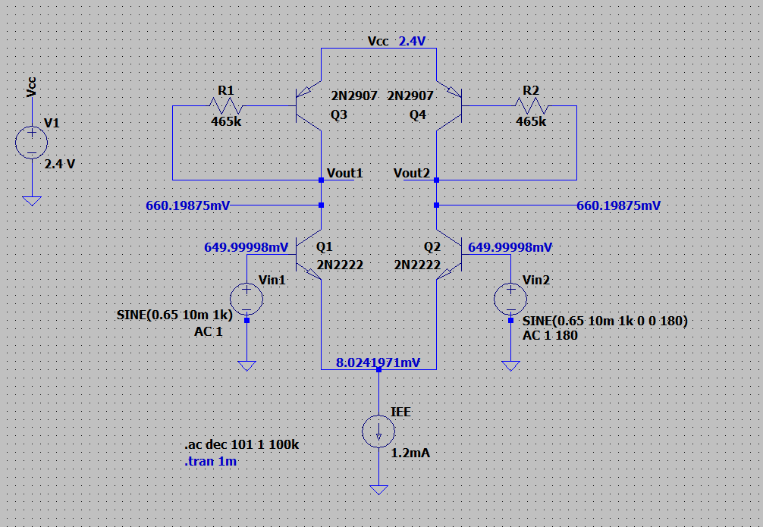

**The AC gain I get is 32.53 dB**

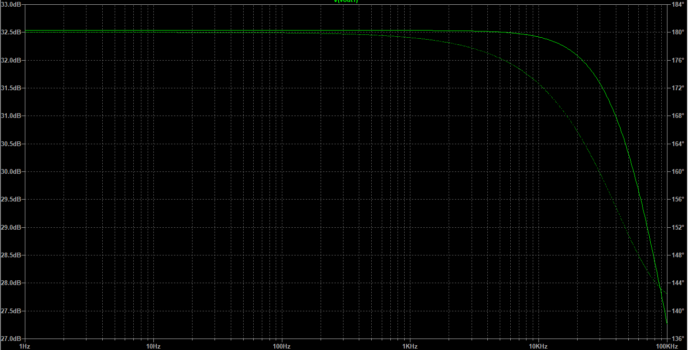

**THE TRANSIENT RESPONSE OF MY CIRCUIT IS SHOWN AS:**

**Vout1 – Vout2: Peak voltage 809mV**

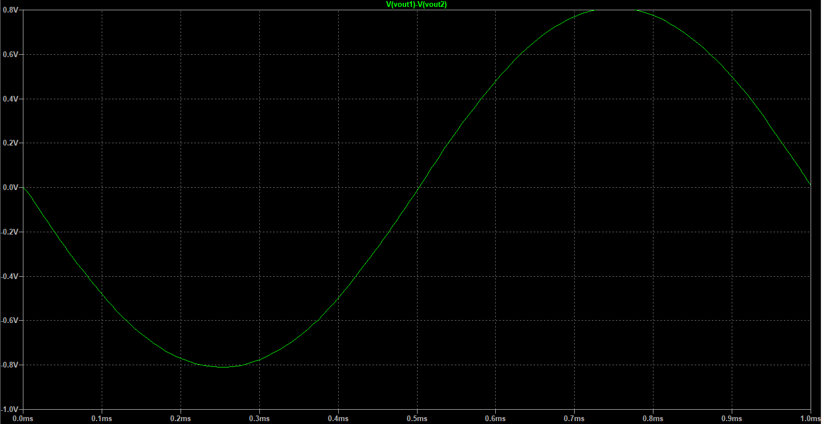

**Vin1 – Vin2: Peak voltage 20mV**

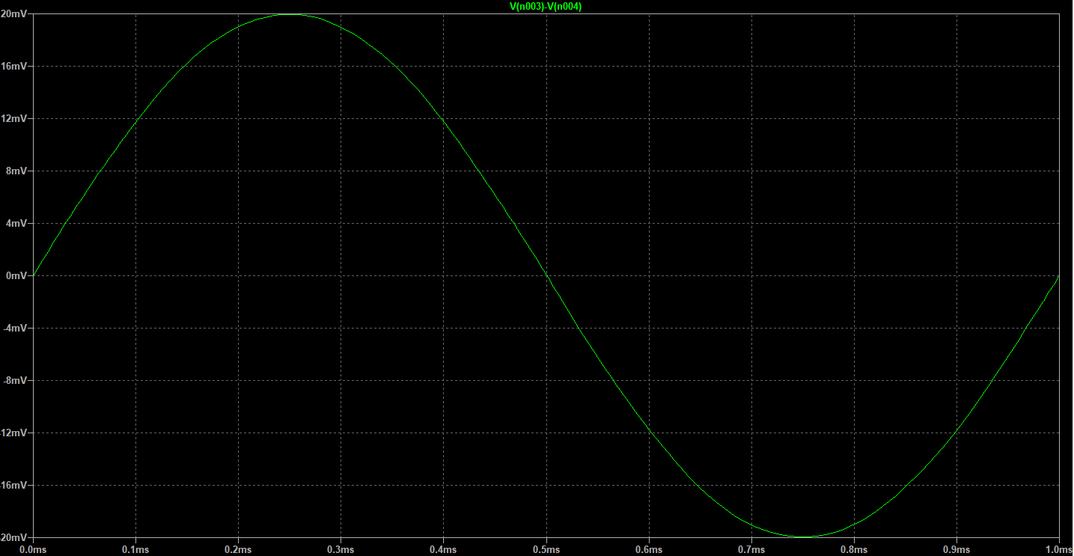

$$GAIN : \frac{809mv}{20mv}=40.45 ; 20log\left(40.45\right)=32.14 dB$$